REPORT ON CONSULTATION

London Borough of Harrow’s consultation on its
Climate Change and Nature Strategy 2023-2030

October 2023

- Introduction & Aims

This report summarises the findings of a public consultation held on the London Borough of Harrow’s draft Climate and Nature Strategy 2023 - 2030. During a three-month period from 20th June to 24th September 2023, Harrow residents, including local businesses and the voluntary sector, were asked about their views on climate change and nature recovery in Harrow, including which actions they would be willing to take across the four key themes included in the strategy.

This report sets out the key findings from the consultation and makes recommendations as to how the Strategic Action Plan can be built upon, to meet the needs of Harrow residents.

The aims of the consultation were:

- To share the Council’s draft strategy with Harrow residents, local businesses and groups; to promote discussion, feedback and questions.
- To understand the views of Harrow residents and local businesses and groups on climate change and nature recovery in Harrow, in order to inform the development of the strategy.
- To identify the practical actions that residents / businesses / community groups are taking and are willing to take, and the key barriers that exist to making more sustainable choices.
- To find out what existing initiatives exist in Harrow focusing on climate and nature, and help the Council understand how they can support and scale existing work and initiatives around climate and nature in Harrow.

- What we did

From 20th June to 24th September 2023, we administered a multifaceted approach to engaging Harrow residents and local groups in discussion around the draft Climate and Nature Strategy.

We asked residents and the voluntary, business and schools sectors:
- How concerned they are about climate change and nature recovery
- How motivated they are to help prevent climate change
- Whether they understand what actions they can take to reduce their environmental impact
- The degree to which being ‘environmentally friendly’ affects their everyday decision making
- How much of a priority climate change should be for the council
- Which practical actions they are/would be willing to take to help prevent climate change and aid nature recovery in Harrow, across the four thematic areas of the strategy
- What the key barriers are to taking (further) action
- What are the local initiatives and projects in Harrow addressing climate and nature

We used online and offline communications to reach residents in Harrow, including:

- Social media messaging
- Online newsletters: Harrow People magazine, My Harrow News email, Harrow Online shared across their platforms
- Print media: Harrow People magazine and posters in Harrow’s libraries
- Three Harrow town-centre drop-in events held on both weekdays and at a weekend
- A webinar with representatives of the voluntary sector from Voluntary Action Harrow
- Meeting with Harrow nature and wildlife conservation groups, Harrow Nature Conservation Forum and Harrow Wildlife Action, and a separate meeting with Harrow’s U3A group
- In person workshop at a Super Traders’ Group meeting and a drop-in webinar for local businesses
- A presentation and Q&A with the Harrow Business Improvement District
- Attending the Harrow Means Business event in September 2023. The team had an exhibition stand at the event and hosted a conference session
- An interactive map of Harrow on the consultation web page for contributors to pin any local climate and nature initiatives they are involved in or aware of

Through the duration of the consultation period:

- 1660 people visited the Climate Change and Nature Recovery in Harrow web page.
- 118 people completed the residents’ survey.
- 58 business survey responses were received.
- We spoke to an estimated further 250 people at the town-centre events, online webinars and other meetings.

- Demographics of contributors

A number of factors limit the representativeness of the survey sample of Harrow residents’, notably:

- The likelihood of respondents to be a sub-group who already have an interest in environmental issues and/or are civically engaged to some degree. The survey results illustrate this, e.g. a high proportion (37%) of respondents are part of a local voluntary group.
- The majority of people we spoke to at the Town Centre drop in events were middle-upper age (50+) and many were retired or unemployed.

However, we endeavoured to make our reach as wide as possible by:
- Including a weekend date as one of the town-centre event days.
- Promoting the consultation as widely as possible across online and offline channels.
- Attending existing meetings such as the Community Touchpoint weekly meeting and business forums.

Interestingly, pairing the town-centre events with the Conversation Café expanded our reach to people who were coming to talk to the Council about other issues. We brought ipads and physical copies of the survey to the event, and there was an opportunity for residents to fill out the survey, copies of which were subsequently uploaded to MyHarrow Talk.

Demographic data of resident survey contributors:

- 97% lived in Harrow, with the remaining 3% living in nearby boroughs of Hillingdon and Brent. Respondents lived across different areas of Harrow.
- Ages range from 27 to 80, with the median age being 48.
- 63% of respondents work in Harrow.
- 6% of respondents own a business in Harrow.
- 37% are part of a voluntary group.

- Interactive map of current initiatives

The interactive map function on the consultation hub web page asked contributors to mark any current initiatives tackling climate and nature in Harrow, with the aim of helping the Council understand what’s out there and sharing this with residents.

There were 28 pins added to the map, showcasing local initiatives with an environmental agenda, focusing on various aspects of the four themes, from food growing projects to energy saving.

Many of the initiatives listed, for example Harrow Cycle Hub, and Sustain IT, have a social and community resilience-building mission. The Council can continue to act as a convenor linking residents with these groups, and highlighting the positive work of the initiatives. It is intended to maintain the map function as an ongoing resource.

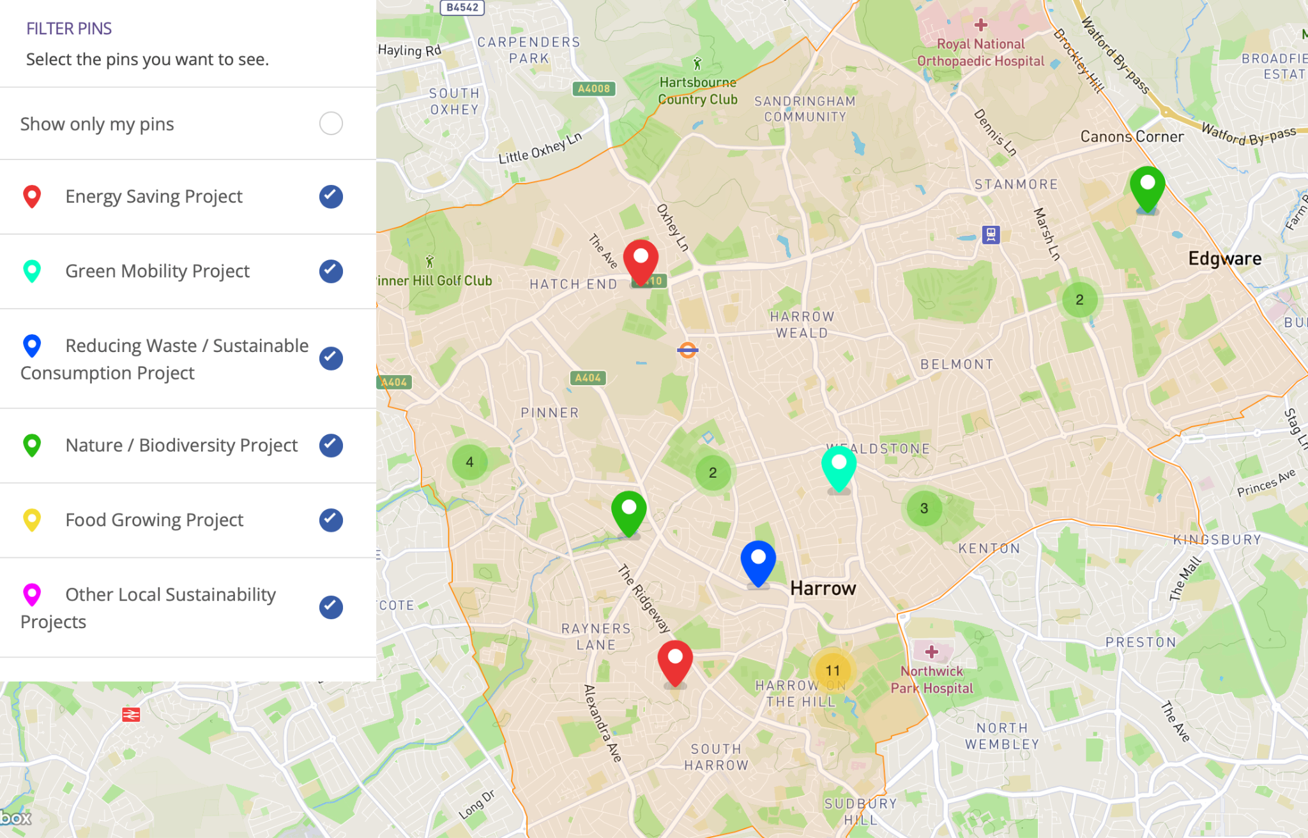

- Key findings and analysis

The sections that follow present the findings of the consultation with individual Harrow residents and some local voluntary groups. We also consulted local businesses and the findings from that element of the consultation are separately set out in the report at the Appendix.

Note: the data presented in graphs is raw data from survey reporting and in-person feedback. The statistics displayed are interpreted in the text of this report as percentages.

5.1 Levels of awareness, understanding, perceived importance and motivation to take action around climate change

Respondents to the survey and feedback from in-person events shows that a high proportion of Harrow residents are concerned about climate change.

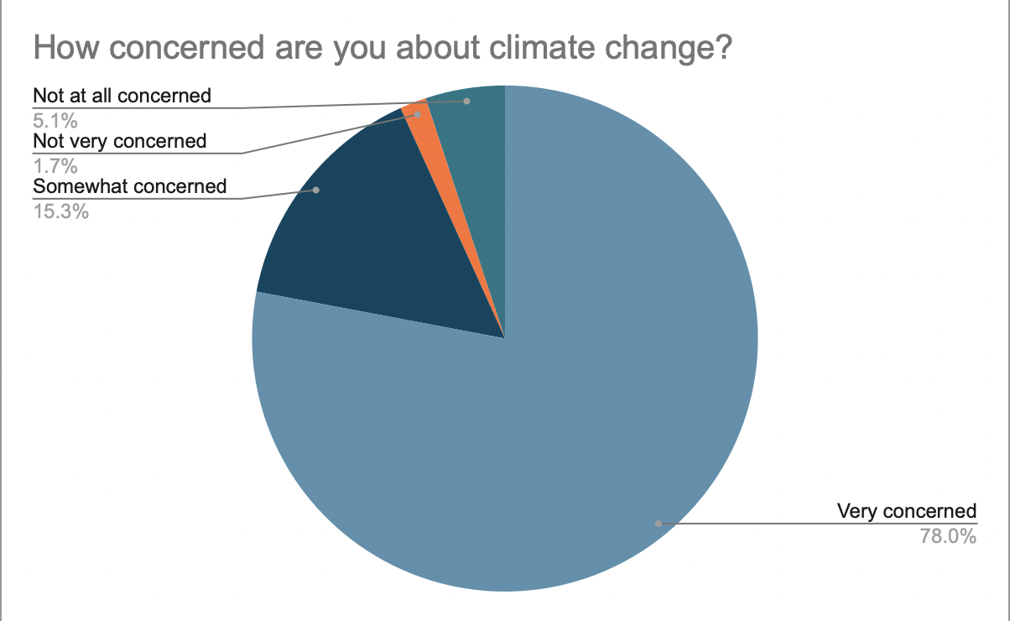
Overall 93% of survey respondents said that they were concerned about climate change. Of these 78% were ‘very concerned’, 15% were ‘somewhat concerned’ and 7% were ‘not very concerned’ or ‘Not at all concerned’.

Respondents were also motivated to help prevent climate change, with 65% answering that they were ‘very motivated’, 25% answering “somewhat motivated” and 7% “slightly motivated”. Overall 97% were motivated to some degree to take action, with only 3% saying they were not at all motivated.

However, responses show that a lot of people who were motivated to prevent climate change do not know what actions they can take to reduce their impact on the environment. Only 45% of total respondents selected “Definitely agree” when presented with the statement “I know what actions I can take to reduce my impact on the environment”. A higher proportion of respondents (47%) said they “somewhat agree”, indicating some level of uncertainty, and a small number (3%) disagreed. The remaining respondents opted for ‘I don’t know’ (5%).

An overwhelming majority of respondents thought preventing climate change should be a top priority for the council. 75% said it should be one of their top priorities, as opposed to it being something they think about, but not a top priority (17% chose this answer) or not a priority at all (7%) and 1% opting for ‘I don’t know’.

In terms of the immediate relevance of climate change to their daily lives, 54% of respondents answered “Yes” when asked if they feel their lives are impacted by changes in climate such as heat waves and flooding. 23% said ‘no’, 20% said ‘maybe’ and 3% said ‘No’.

5.2 Taking action across the strategy’s four thematic areas

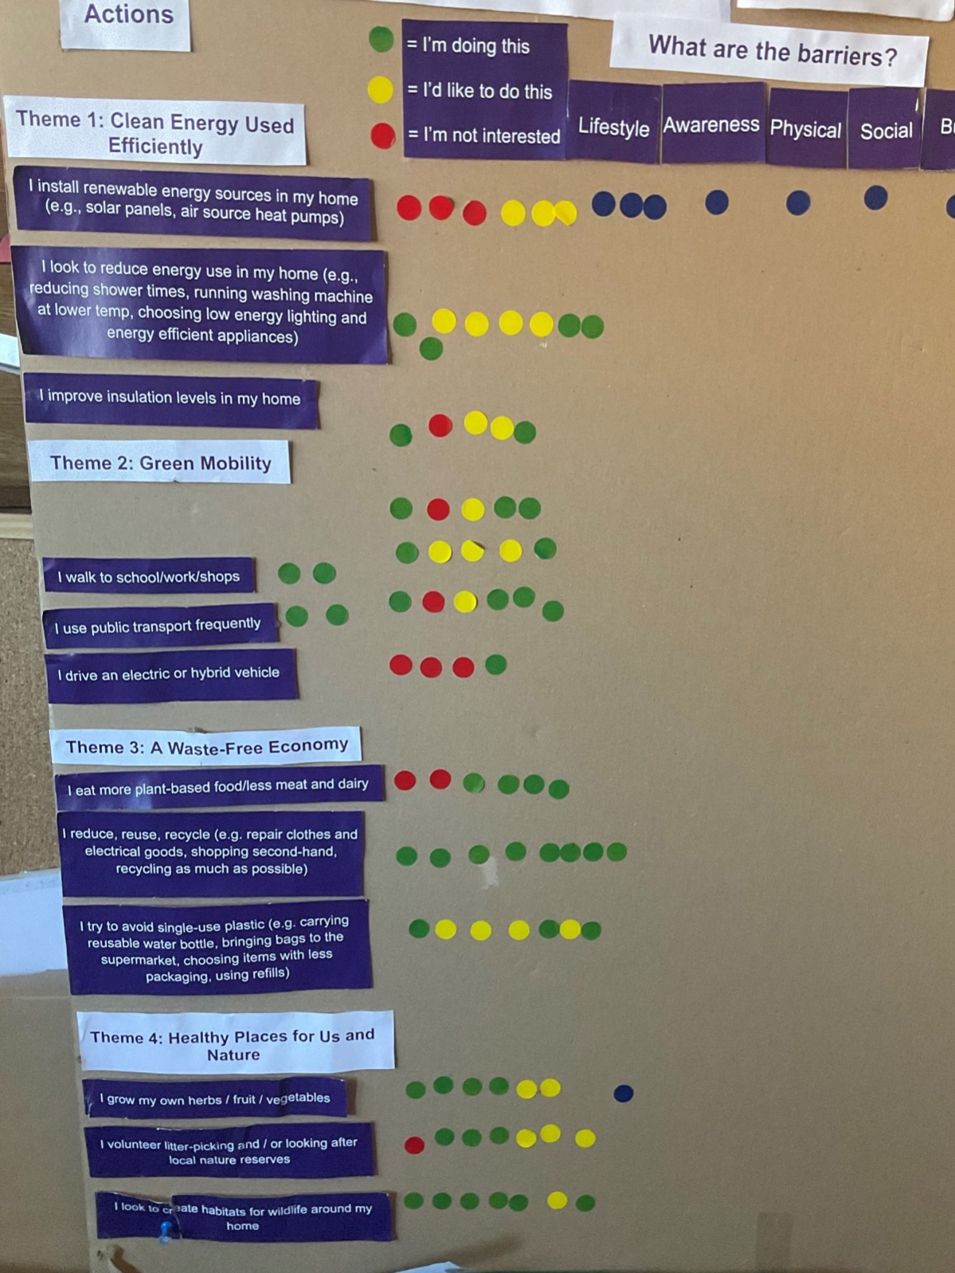
Note: The interpretations of graphs from survey data (listed as percentages in the report) also include additional feedback collected around the actions under the four themes at town-centre events. This was collected by means of a sticker board - pictured here.

Residents were asked whether they are currently taking, or would consider taking, a number of actions chosen for their relevance to, and potential impact, in each theme of the strategy.

For each theme, they were asked to select what the main barriers are to taking (further) action.

Theme 1: Clean Energy Used Efficiently

What are residents currently doing?

- 55% are using a renewable energy provider
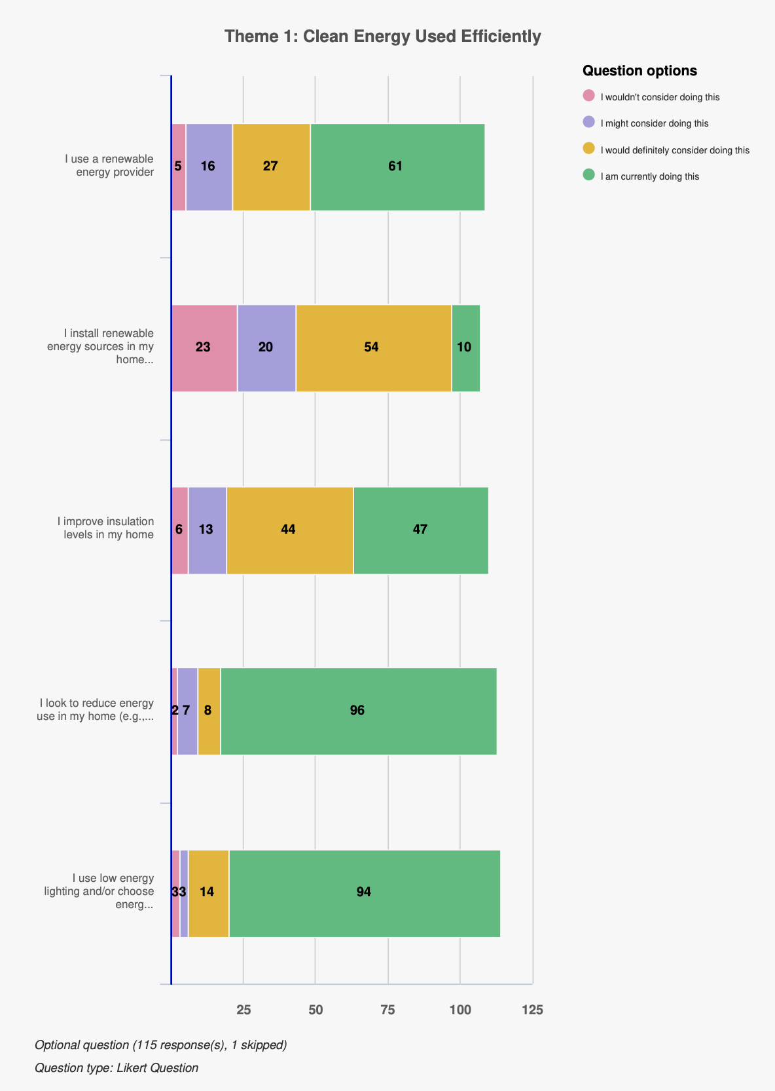
- 9% are installing renewable energy sources in the home
- 43% are improving insulation levels in the home
- 85% of residents are reducing energy in their homes
- 83% are using low energy lighting and/or energy efficient appliances

What would residents consider doing, and what are the barriers - analysis

This section reflects on whether residents would consider taking actions they are not already taking, and the main barriers to taking these actions.

- Over half of respondents were already using a renewable energy provider, and the majority of the remainder would/might consider doing so
- 43% of respondents were already improving insulation levels in the home, and again the majority would/might consider
- There were high levels of those already reducing energy use in the home and choosing
low energy appliances with the majority of the remaining willing to consider doing so

The main barriers:
- Budget - 60% selected as a barrier
- Physical - 27%
- Other - 20%
- Awareness - 18%

Installing renewable energy (solar panels / heat pumps) had the fewest number of people already doing this (8%) but three quarters of those who had not yet done so would consider this action.
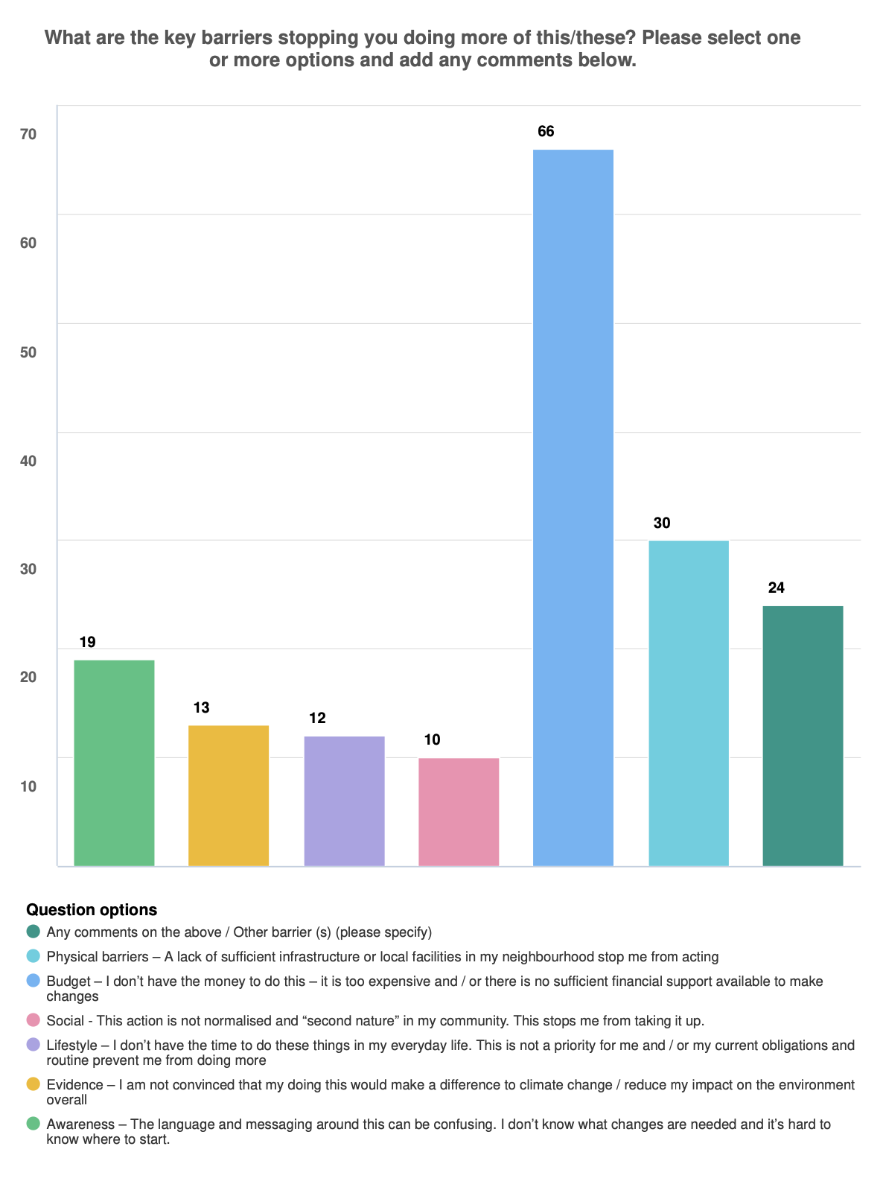
This move to renewable energy sources and the installation of insulation are two actions which currently have relatively low uptake but high levels of motivation, indicating future areas of focus.

The main barriers to taking these actions are budget (overwhelmingly) and physical.

Conversations at town-centre events told us that the primary motivation behind making these choices is often cost-saving, however reducing environmental impact is a secondary motivation.

All of the most popular actions that people would consider have additional budget implications. Tariffs for renewable energy providers are often more expensive than fossil fuel suppliers; installing sophisticated insulation and renewable energy sources in the home require significant budget (though would offer longer term cost-saving benefits).

The Council could support residents in this area by sharing guidance on low-cost options to insulate their homes and switch to renewable energy providers.

It was noted in comments on the survey and at the events that for tenants the making of long-term energy adjustments to the home was not in their gift. The Council might consider outreach to landlords with support in this area, e.g. targeted communications sharing advice.

Most respondents are already looking to reduce energy use in their homes and are using energy-saving lighting/appliances. Budget and physical barriers are less significant when using energy-saving lighting/appliances, so this is a key area where the Council can share guidance and support on making these switches.

To summarise, there are many residents already taking measures to move towards green energy; residents surveyed are motivated and engaged to take (further) action to reduce energy use, but budget and lack of physical capacity are significant obstacles. Quick wins for the Council that aren’t resource-intensive would be focusing on communications, helping residents to understand the low-cost lifestyle changes and home adjustments they can make, and promoting government schemes that assist with the costs of retrofit (eg Boiler Upgrade Scheme).

Other patterns in comments from survey responses and in-person feedback

- Some concern was expressed by a number of residents about the complexity of retrofit (eg solar and heat pump installers) and navigating the market for these products
- Residents asked if planning guidance could be given around common retrofit actions – eg window replacements, solar panels and heat pumps – particularly in planning conservation areas.

Recommendations for the Council for Theme 1: Clean Energy

- Promoting the new Harrow Energy Advice Line to residents and voluntary organisations

- Signposting to the Energy Saving Trust and reliable advice on retrofit, improving insulation levels and installing simple energy saving measures in homes and business premises, highlighting the cost-saving benefits

- Considering how landlords can be incentivised to improve insulation levels and install solar and heat pump technologies in homes / business premises

- Developing clear planning guidance on retrofit, including conservation areas

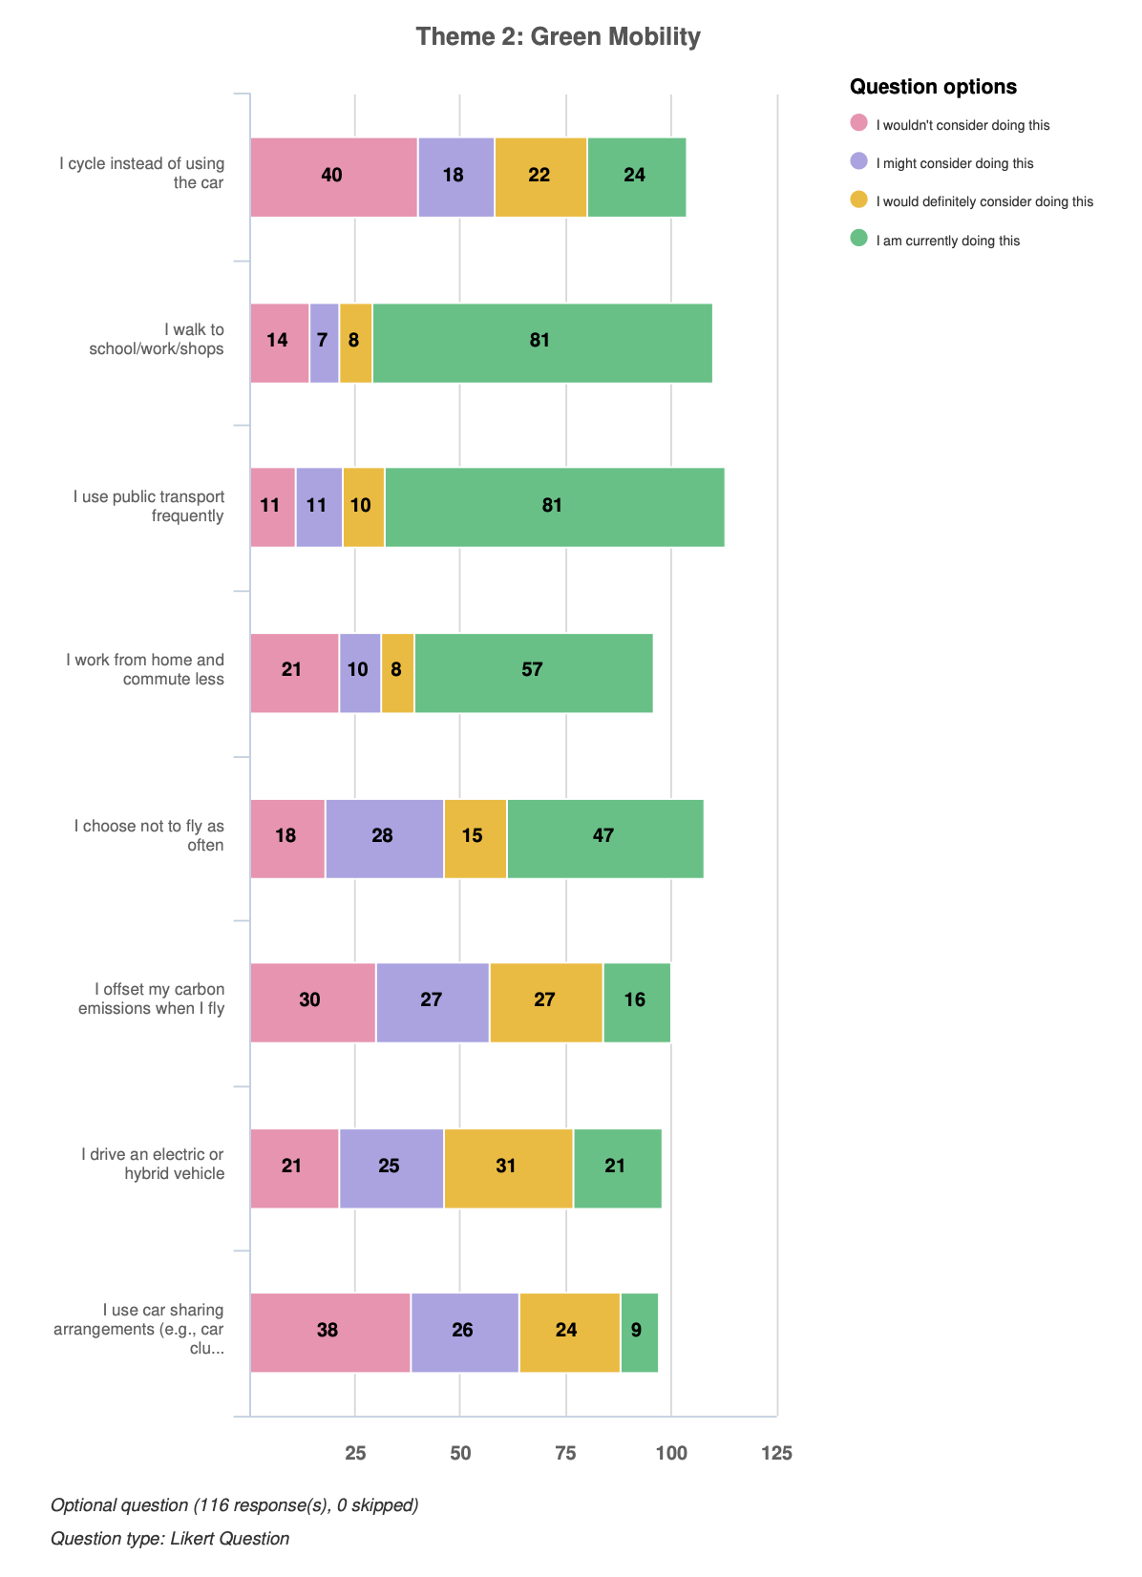
Theme 2: Green Mobility

What are residents currently doing?

- 20% of residents surveyed cycle instead of using a car
- 72% walk to school/work/shops
- 72% use public transport frequently
- 49% work from home and/or commute less
- 40% choose not to fly as often
- 14% offset carbon emissions when they fly
- 22% are driving electric or hybrid vehicles
- 8% use car sharing arrangements

What would residents consider doing, and what are the barriers - analysis

This section reflects on whether residents would consider taking actions they are not already taking, and the main barriers to taking these actions.

The most popular actions that respondents who are not already doing would/might consider doing are:
- 56% of people who weren’t already would/might consider walking to school/work/shops
- 67% would/might consider using public transport more frequently
- 70% would/might consider flying less often
- 64% would/might consider offsetting carbon emissions when they fly
- 64% would/might consider driving an electric/hybrid vehicle

The main barriers:
- Physical: 43% selected as a barrier
- Budget: 41% selected cost as a barrier
- Other: 37%
- Lifestyle (not having the time): 18%

A high number of people already walk and use public transport, and nearly half work from home and/or commute less.

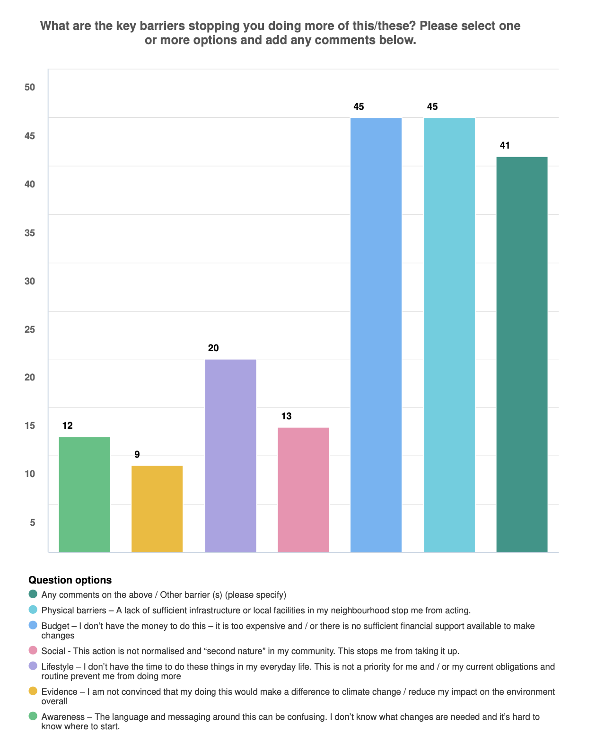
It is important to note that some of these actions are context-dependent and presumptive that residents have the budget to make these choices in the first place. Lifestyle and physical barriers, such as physical ability to walk or cycle, and whether work is desk based, make certain actions non-applicable to some residents. It was noted at town-centre events and in comments that flying is not an option for many people in Harrow due to cost.

That being said, a considerable number of people who weren’t already choosing to fly less often and/or offsetting carbon emissions when flying said they would/might consider this (70% and 64% respectively). In-person feedback highlighted a significant obstacle for certain communities in Harrow who need to see loved ones overseas.

A relatively low number (18%) of survey respondents are driving electric vehicles, but of those who aren’t, 64% would/might consider, likely contributing to the top-most selected barrier ‘physical’ (lack of infrastructure). This highlights the need for the Council’s ongoing investment in infrastructure for electric vehicles.

Only 34% of those who weren’t already commuting less would/might consider this. It is worth noting that this could well be due to the ‘physical’ / ‘lifestyle’ barrier or not having a desk-based job, or whether the respondent is employed or retired.

Other patterns in comments from survey responses and in-person feedback

- There is willingness to consider cycling as a cost-effective alternative to the private car, but residents cited a lack of suitable segregated infrastructure to do so safely. This includes properly connected routes, safe separation from other road users with wide enough cycle lanes, and cycle storage in parks and at public facilities. This area would require concerted long-term infrastructure improvements, but could be transformative.
- There is a need for more publicly accessible electric vehicle charging infrastructure, with emphasis on streets for those without dedicated parking.
- Harrow has a private car centric culture, which leads to air pollution and emissions - interventions needed to change this – some support was expressed in the consultation responses for ULEZ, properly thought through LTNs, 20mph zones, car and bike / EV bike share schemes.
- There is support for expanding school streets, and it was noted other neighbouring boroughs have more.
- Better communications are needed to illustrate environmental damage caused by fossil fuel vehicles, and to advocate active travel and alternatives to using a private car – e.g promoting Street Tag, cycle training.
- Residents commented that it is excellent that TfL has introduced a number of electric buses in Harrow - this is really welcomed. However, there was some feedback that diesel buses are still idling unnecessarily, e.g. when drivers changeover.
- Residents asked if the Council can do more around expanding the use of car clubs in Harrow.
- It was noted that bicycle parking is not always plentiful, for example at medical centres – residents asked what can the council do to encourage greater provision on its own sites and encourage private owners to do the same.
- It was stressed that there is a need for a Green Mobility approach to be inclusive and non-discriminatory. This is borne out by the findings of the Equality Impact Assessment that accompanies the Strategy, which emphasises for example the need for continuing vehicular access for access impaired individuals.

Recommendations for the council for Theme 2: Green Mobility

- Feedback supports the actioning of existing Strategic Action Plan (SAP) action to expand and improve cycle and walking routes across the borough. The Council should focus on developing a fully integrated, safer cycle infrastructure (and walking routes) where possible, given 43% of people who are not already cycling would or might consider doing so if these factors were addressed.
- Building on point 6.2 of the SAP, the Council could consider trialling a Bike / EV Bike Hire Scheme, and improving cycle storage at key public locations.
- Results affirm the importance of maintaining a good public transport system. 88% of respondents are either currently doing this or would consider it.
- Residents’ feedback supports the Council’s planned expansion of the car club offering (SAP, 5.5). Only a small number of respondents use car sharing arrangements, yet 57% of those who are not currently doing this would consider it.
- Use communications to promote Street Tag and other active options.
- Residents’ comments show support for the Council’s planned EV charging expansion (SAP 5.2).
- Explore ways to improve air quality monitoring and data capture to inform target setting.
- Consider how to improve the liveability of highways infrastructure (for example, tree planting / biodiversity enhancements) that encourage more active travel.

Theme 3: A Waste-Free Economy

What are residents currently doing?

Of all the four themes, survey responses show the most action, and willingness to take action, around reducing waste.

Whilst it should be noted that respondents are likely to be already engaged on these issues, the survey responses nevertheless reflect a significant effort to reduce waste:
- 79% of respondents eat leftovers or meal plan to reduce food waste.
- 62% choose items wrapped in less packaging, and 74% try to avoid single-use plastic.

High levels of reuse are also prevalent:
- 90% of respondents donate items to charity shops.
- 93% carry their own bags to the supermarket.
- 76% carry a reusable water bottle.

Recycling levels among respondents are high, but more could be done to promote recycling of textiles and e-waste:
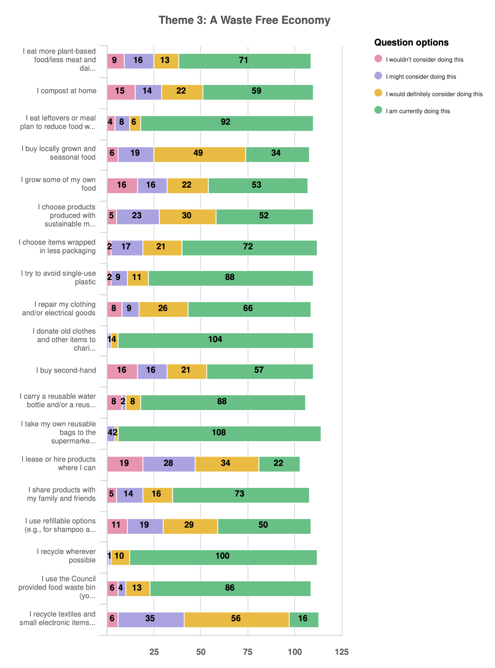
- 89% recycle wherever possible, and a further 10% would or might consider recycling wherever possible.
- 79% use the Council provided food waste bin, and a further 16% would consider doing so.
- Only 14% recycle textiles and small electronics, but a further 81% would or might consider doing so.

The in-person feedback at the events also reflects a significant effort among Harrow residents to minimise waste, with 100% saying they reduce, reuse recycle wherever they can, e.g. repairing clothes and electrical goods, shopping second hand and recycling as much as possible.

67% of people surveyed at the events said they currently eat more plant-based food and dairy, and 43% try to avoid single use plastic - with the remaining 57% saying they would like to do this.

What would residents consider doing,and what are the barriers - analysis

Almost all of the actions under ‘A Waste-Free Economy’ are already being taken by at least half of respondents (noting that these level of uptake is likely to be higher than in the borough as a whole, taking into account less engaged resident groups).

Buying locally grown and seasonal food, and recycling textiles and electronic items are the only two actions that a lower number of respondents (30% and 14%, respectively) are already doing.

‘Awareness’ and ‘Infrastructure’ are key barriers for this thematic area (see chart on the next page), therefore the council might consider helping to share and scale local initiatives selling local and seasonal produce, and sharing information widely on recycling textiles and electronic items.

Whilst the results demonstrate a significant commitment to reducing waste in Harrow from respondents, the main barriers listed were ‘physical’ and ‘awareness’. A suggested focus for the council is signposting residents to information around how to access existing recycling infrastructure and consideration as to whether this can be improved / extended.

Other patterns in comments from survey responses and in-person feedback
- There is an existing initiative in London to borrow household items, the ‘Library of Things’. Residents expressed an interest in having this initiative introduced to the borough.
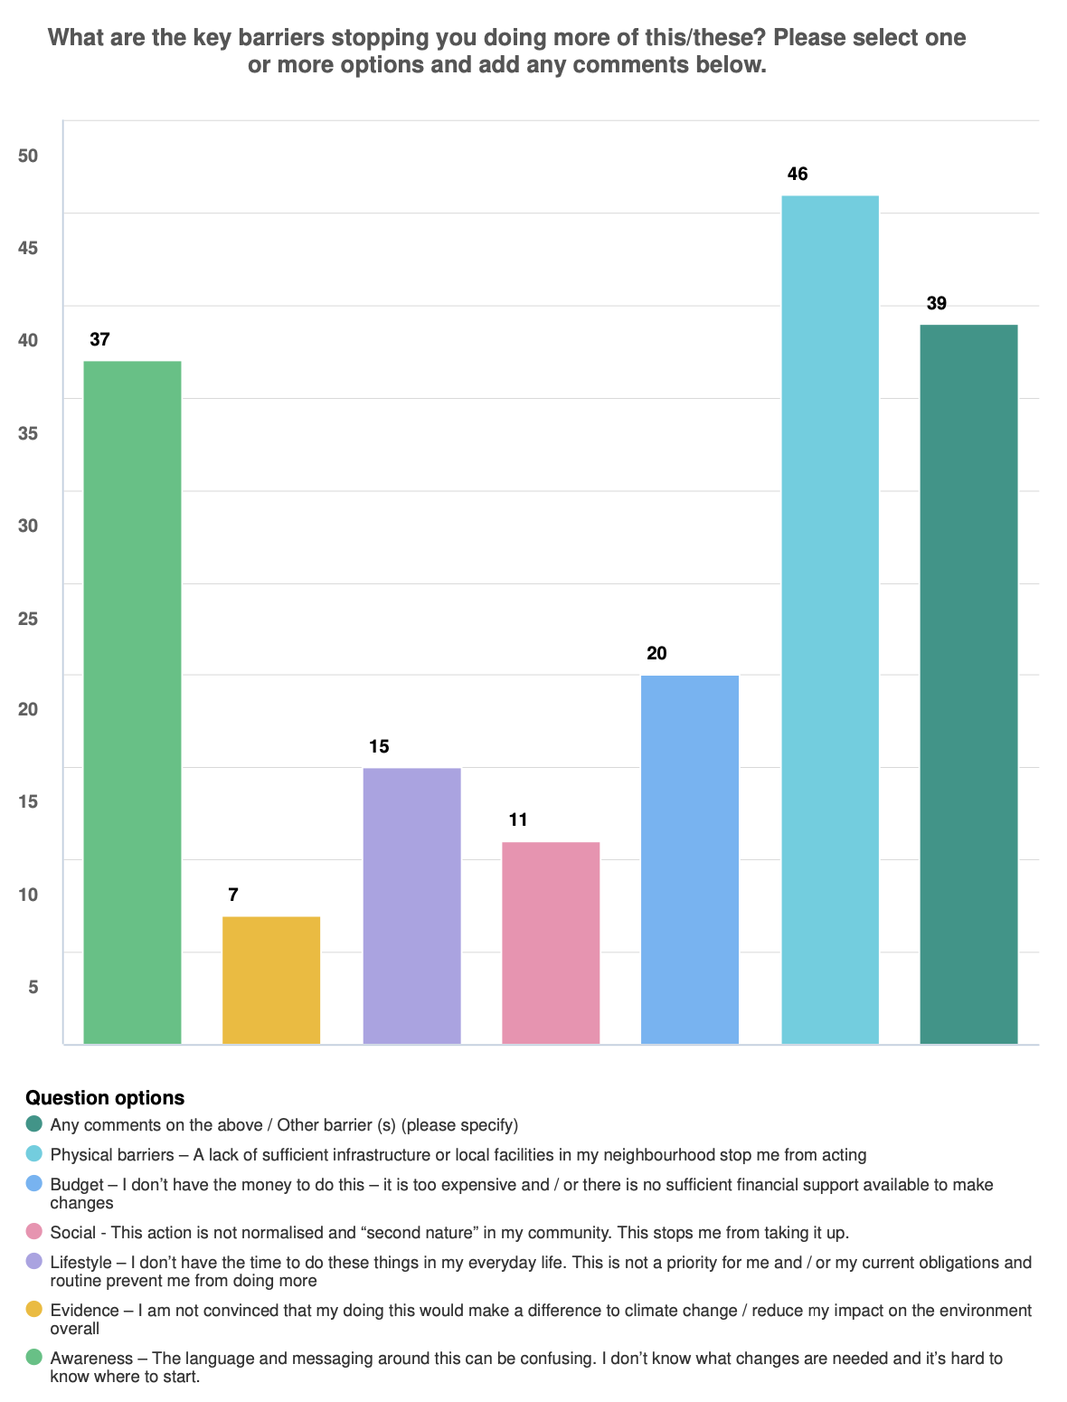
- It was noted by a number of contributors, including Voluntary Action Harrow in the online webinar, that the Council should continue to develop the relationship with existing volunteer groups such as Harrow Litter Pickers. The Council could highlight the work that is being done and work collaboratively with these groups to share info and raise awareness around behaviour change and culture of littering (including HMOs, food waste in flats, fly tipping and dumping).
- It was also noted that littering is still a big problem across the borough, and needs a work to change the culture around this, encouraging people to take pride in their borough.
- In-person conversations revealed an overall low awareness of TRAID doorstep textile collection service.
- Awareness on where waste goes and how to recycle difficult items (such as plastics and film) is low. More communications are needed around this.
- Feedback revealed there is a lack of infrastructure to recycle beyond the home and waste and recycling centre (such as in parks or car parks). However, this can be difficult to manage as often there are high levels of contamination.
- There is demand for more refill facilities.
- Residents commented that information about where Harrow’s waste and recycling goes is hard to find - they asked that the Council signpost clearer information about this, which would give residents confidence that recycling is worth doing.
- Residents commented that on one occasion some staff were seen emptying green and blue bins into the same truck - they asked why this happened, and stated it undermines confidence in recycling. Whilst this may well have been justified (eg contamination), good information about this (as above) would help to maintain confidence.
Recommendations for Theme 3: A Waste Free Economy
- Support residents to minimise waste by providing and sharing clear information on where Harrow’s waste and recycling goes - this would help instil confidence that recycling is worth doing.
- Signposting residents to existing infrastructure and schemes to reduce waste e.g., council-provided food bins.
- Explore the opportunity, including funding requirements, for the Council to introduce a Library of Things at a suitable location.
- Further promote TRAID, the doorstep textile collection service for residents, as conversations revealed most people don’t know about this.
- Improve communications as a whole around waste, for example sharing where waste goes; food (promoting the Eat Like a Londoner Campaign); and textiles repair.
- The Council could consider expanding recycling infrastructure beyond the Harrow waste and recycling centre e.g., Bottle banks in car parks (noting that the right location is crucial to avoid contamination and Anti Social Behaviour)
- More awareness is needed around single-use plastic, e.g. plastic films - residents noted that the information is confusing.
- Continue to share comms around behaviour change and the culture of littering, encouraging residents to take pride in keeping their borough clean, including sharing praise and support for existing work being done by Harrow Litter Pickers and others.

Theme 4: Healthy Places for Us and Nature

What are residents currently doing?

- 81% regularly visit their local park / 75% regularly visit open spaces
- 55% grow their own fruit or vegetables
- 64% make efforts to create more sustainable wildlife around their home, with bee-friendly flowers and bird feeders etc
- 68% use peat free compost
- 38% volunteer to preserve local environments and participate in litter picking
- 86% look for ways to save water

What would residents consider doing and what are the barriers - analysis
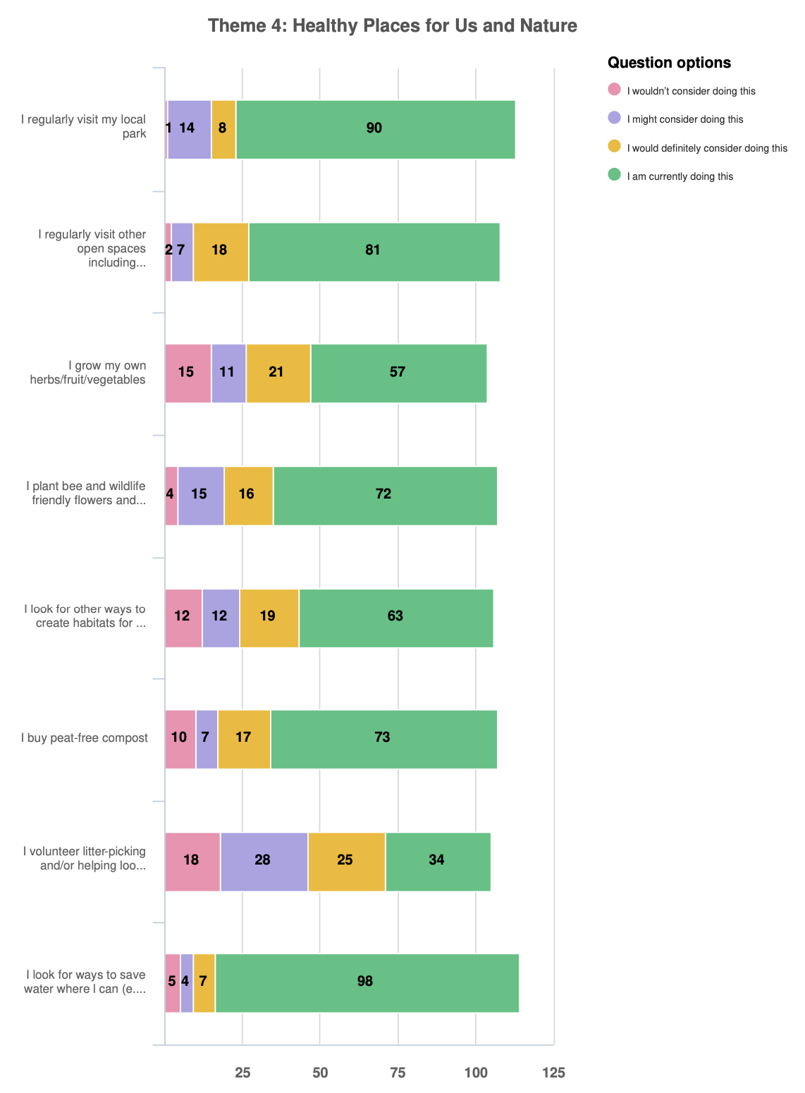
The survey results reflect an overall keenness to do more around helping protect the natural environment, with numbers of people who wouldn’t consider each of the actions very low:

- Less than 1% of people would not consider visiting their local park.
- Only 2% of people wouldn’t consider visiting open spaces
- 14% wouldn’t consider growing their own fruit and veg
- Less than 5% wouldn’t consider using bird feeders etc to aid local wildlife
- 13% wouldn’t consider looking for other ways to create habitats for local wildlife
- Less than 10% wouldn’t consider using peat free compost
- 19% wouldn’t consider volunteering litter picking

What are the barriers?
- 5% of people are unconvinced of the evidence surrounding climate change and ecology
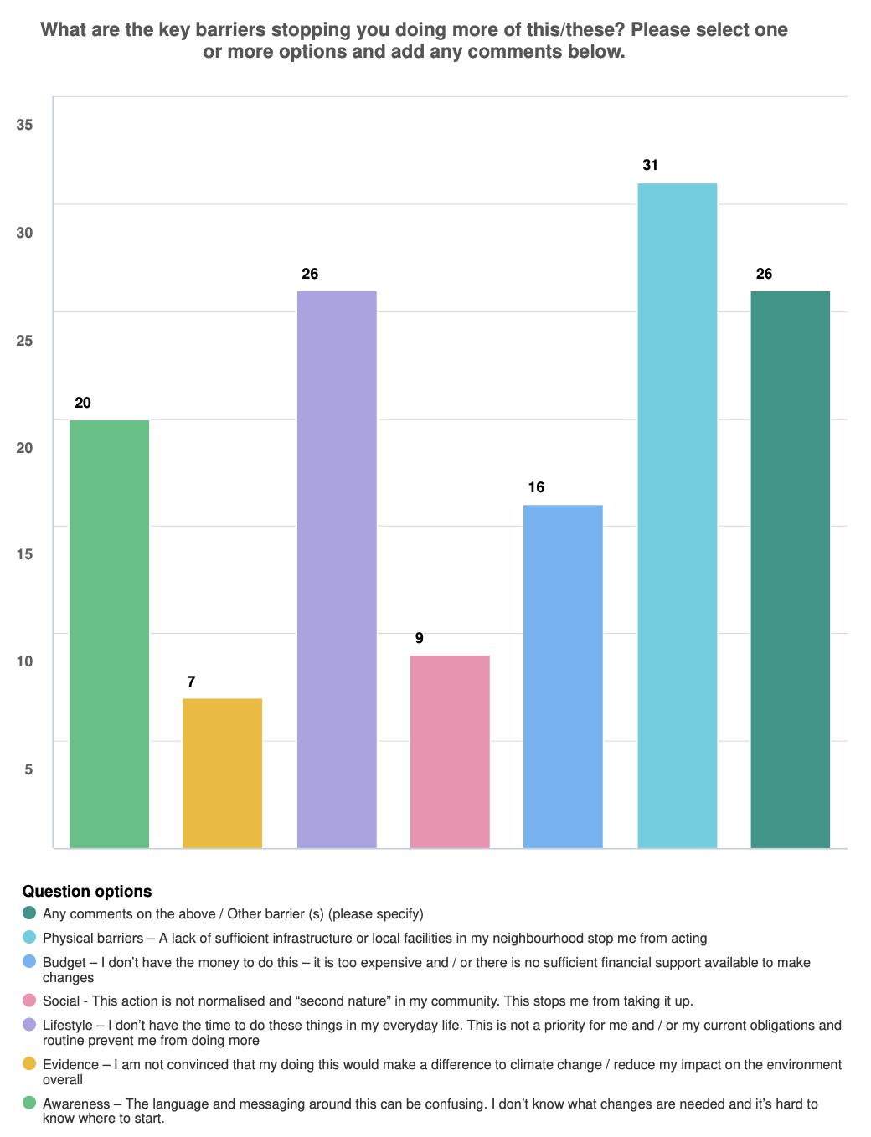
- 19% said that their lifestyle conflicted with their ability to live ecologically
- 6% said that social normality inhibited their ability to live more ecologically
- 11% said that their budget prevented them from participating
- 22% are prevented by physical barriers.
- 14% said they were lacking the awareness to help

Clearly, there is a willingness to visit local spaces and parks to engage with the environment, and signposting residents to these and borough events should continue to be a communications focus.

Most people would at least consider making lifestyle choices that benefit their environment, with less than 5% unconvinced of evidence surrounding environmentalism. The people surveyed are therefore generally informed and willing to engage with nature, and this ought to be maintained. Although awareness is generally quite high in the survey group, across the borough it is highly likely that there are still large numbers of residents for whom awareness is a barrier, therefore sharing of good information and resources should continue.

Other patterns in comments from survey responses and in-person feedback
- Residents discussed their support for the continuation of actively improving biodiversity in our parks, open spaces, housing areas and verges.
- There was concern repeatedly expressed over the concretisation of front and rear gardens and removal of hedges or plants.
- Residents are keen to see more tree planting in the borough’s streets and open spaces (Pinner Park School was cited as a good example).
- Nature-positive outputs from new developments should be built into planning requirements – for example swift bricks, green rooves.
- Residents commented that the Council need to develop a vision for natural capital in the borough and hard targets for nature recovery, linked to climate resilience and including a focus on water pollution.
- Although survey responses indicated high awareness, we learnt from in-person feedback at the resident drop-in sessions that some people are not aware of Harrow’s open spaces such as the borough’s Nature Reserves.

Recommendations for the Council for Theme 4

- Expanding biodiversity projects on council open spaces, parks and verges (noting the importance of choosing the right site and good communications), to include upskilling of the Green Team

- Working with existing volunteers involved in nature and conservation activities to showcase their work and expand volunteer participation

- Better signposting of residents to our parks, open spaces and nature events, also highlighting the actions that individuals can take to enable the recovery of nature in their own private spaces

- Developing a medium term and long-term vision for nature and natural capital in Harrow working with Harrow Nature Conservation Forum and other local groups, informed by good data and target setting

- Developing our Local Plan in a way that reserves space for nature and consider the levers available to the Council to tackle the concretisation of gardens

- Raising awareness with local businesses of supply chain risks and ecosystem dependencies as part of Harrow’s business support programmes, to include consideration of a relevant case study (eg a local restaurant business).

5.3 Consultation with the Voluntary Sector, represented by Voluntary Action Harrow

We met with Voluntary Action Harrow to find out what the voluntary sector is doing across the four themes of the strategy; what the challenges are and where the opportunities lie for the Council to support or scale existing work.

Voluntary Action Harrow is the largest volunteer network in Harrow, so they are well-positioned to represent the views of the wider volunteer sector.

VAH emphasised the shared value of acting in the greenest way possible across the sector. However, although making greener choices is a priority, it is secondary to budget considerations, and it was noted that often making more environmental decisions is unaffordable due to very narrow budgets across the sector.

Clean Energy: The voluntary sector recognise and emphasise the importance of clean energy for future sustainability - regular newsletters within the sector report on local progress in this area. However, some key barriers were noted, preventing the sector changing their operations to cleaner or lower energy options.

Foremost amongst these, volunteer organisations don’t usually own the buildings in which they operate, so they asked how the Council can incentivise landlords to invest in their buildings.

The sector shares information around clean energy with its audiences (though local newsletters and the like), but they noted lack of education around this making it challenging task to explain the topic in an accessible way.

Green Mobility: VAH noted that volunteers usually use their own cars instead of car-sharing arrangements. They noted that there is a big car culture in Harrow – much discourse is anti-ULEZ and pro car, this can be seen on social media, for example. It was suggested that giving greater weight in comms to public health schemes, cycle networks and groups and volunteer groups operating in this space would help to change this culture.

Similar to the responses given in residents’ survey, VAH commented on the lack of safe cycle networks in the borough - they noted road width as a main obstacle here, and that existing cycle networks feel unsafe. VAH also noted that many people don’t have their own driveways, so on street EV charging should be prioritised.

A Waste-Free Economy: VAH told us that reducing waste is one area that the volunteer sector is really good at. This is not necessarily always coming from an environmental perspective, but is also due to cost and limited resources, and the “make do and mend” attitude of the voluntary sector. They commended the work of Harrow Litter Pickers and encourage the council to collaborate further with the group.

They noted that, borough-wide, there are social initiatives redistributing food that are widely used (including food banks), refurbishing and sharing tech devices (Harrow Sustain IT), and sharing general household items. Charity shops are also a key cultural aspect of Harrow that helps support a waste-free economy. VAH suggested that considerable learning could be shared by older generations in Harrow, and highlight their attitudes towards waste. This corroborates a number of comments received at the drop ins from older people who indicated that a culture of waste is shocking to see today, and was not so prevalent in their youth when more goods were for example repaired.

VAH were supportive of establishing a Library of Things in Harrow, if a suitable location and funding could be found. They considered that there would be demand in the right location.

Healthy Places for Us and Nature: There are key voluntary groups doing conservation work in Harrow. VAH commended their work and their drive to protect green spaces in the borough.

VAH shared that many residents don’t realise that there is so much wildlife within the borough’s nature reserves. The Council could do more to highlight this and encourage walking and getting into the outdoors, focusing on reaching groups that are less engaged and using existing networks to do so.

5.4 Feedback from Harrow Nature Conservation Forum and Harrow Wildlife Action
Harrow Nature Conservation Forum (HNCF) and Harrow Wildlife Action submitted a detailed response to the consultation, which was subsequently discussed with lead members and representatives from those organisations.
The two groups represent a significant cohort of nature conservation volunteers in Harrow - HNCF has worked closely with the Council over the past four decades in the management and care of Harrow’s nature reserves – and their input is valuable particularly for the fourth Strategy theme of Healthy Places for Us and Nature.
The groups pledged their support and stressed the pivotal role of the Council in acting ‘boldly and decisively’ in its contribution to preventing climate change and recovering nature. They emphasised the urgency of getting this right and acting immediately across Harrow, commenting that “The sheer scale of biodiversity loss and destruction across our borough points to the need for crisis level intervention”.
As methods of engagement, they pointed to the overall importance of ‘education, communication and positive encouragement to residents’.
Their response to the strategy headlines with a call for Harrow Council to craft a long term (Nature 2050) and a medium term (Nature 2030) vision for the borough. It is noted that data and target setting also needs to be improved to inform more detailed action planning to deliver these visions.
Other key points / asks include:
- More ambitious tree planting programme on streets and residential roads and incentivising residents to plant trees in their own gardens
- Extending well beyond the minimum statutory 10% threshold for biodiversity net gain, when that requirement is introduced in the borough for new developments
- Support for upskilling of the Harrow Green Team in managing open spaces in a more nature- orientated way
- The key role that nature-based solutions play in improving resilience and adaptation to the effects of climate change, for example the role of planting in helping to prevent heat islands
- Consideration of how residents can be incentivised to retain / enhance planting and habitat creation or own land over the paving of driveways and gardens
5.4 Other General Comments
The Strategy was welcomed by a clear majority of respondents to the consultation, who felt that the overall scope of the four thematic areas was comprehensive. A number of additional overarching points were raised, including:

- The key convening role of the council to promote and bring together community initiatives that tackle climate change and nature using its existing borough networks (voluntary sector, statutory partners, faith groups, schools).

- The central importance of education and active, culturally inclusive, communications to and from residents and businesses, and within the Council itself, across all of the thematic areas.

- Whilst comprehensive in overall scope, it was noted by some respondents that target setting and specific actions to achieve the outcomes needs to be further developed under the strategic action areas.

- Governance and decision making: consideration of climate and nature impacts needs to be better embedded in council decision making.

- It was noted that young people and schools have a crucial role in terms of influencing behaviours now and in the future.

- The impact of food and climate friendly diet choices has relatively low awareness (although some communities are already vegetarian) but has large role in emissions.

- It was noted that the effect of climate changes that are already ‘locked in’ are yet to be fully felt, therefore the development of resilience and adaptation measures that also build the borough’s natural capital (eg tree planting and nature based solutions to increase flood resilience and combat drought) will be crucial, alongside mitigation through carbon reductions.

APPENDIX – SUMMARY REPORT ON BUSINESS ENGAGEMENT
[see separate document]

